How to set your participant name in a Zoom meeting

- While you join your meeting

- From your PC

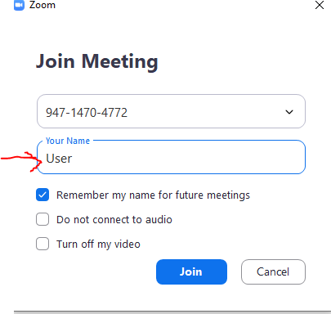

- From mobile phone/Tablet
When joining from a mobile phone and Tablet, you must set the name of the phone/tablet to be as per the standard participant name as it will automatically take the device name when joining the meeting.
This in done in general in Settings.

- In case you joined and admitted to the meeting with the wrong name

You can change as per the following step by step:


Click participants above



Hover over your name, click more, Rename and you will be prompted to change
